# Law Office of Robin T. Cravey Social Media Posts



Your lawyer knows what he or she is talking about, so listen to their advice carefully.

The Law Office of Robin T. Cravey -- the legal representation that's there for you!

(512) 236-9655



You've probably heard the term estate planning plenty of times before, but do you really know exactly what it entails? Learn more about estate planning by calling (512) 236-9655



Did you know that most home owners and real estate professionals, when purchasing a home, consider hiring a real estate lawyer vital? http://www.craveylaw.com/



Need a lawyer? Call Robin Cravey, a lawyer with a plan! (512) 236-9655



When you're planning your estate for future generations, there is no room for error.

The Law Office of Robin T. Cravey knows how to flawlessly execute your wishes and plans.

(512) 236-9655



Real estate lawyers devote their attention and expertise to issues involving real estate. Protect the future of your family by trusting the Law Office of Robin T. Cravey.

http://www.craveylaw.com/ (512) 236-9655



The Law Office of Robin T. Cravey handles every client matter with the unique, special care they need. Our clients have an attorney who is heavily involved in their legal matters, working towards creative and analytical solutions. (512) 236-9655



Your estate can be threatened by a variety of factors, including financial crises, new legislation, and more. That's why we offer a variety of solutions to help you protect your estate for future generations. Call (512) 236-9655 to learn more.



Close your real estate deal the right way with representation from the Law Office of Robin T. Cravey.

http://www.craveylaw.com/



Robin Cravey is an attorney who is trusted to represent all clients. http://www.craveylaw.com/



When you need an effective tool for estate planning and smoothing the process of probate, it's time to get a trust agreement. Preserve privacy and prepare your estate for an easy transition with the help of Robin Cravey.

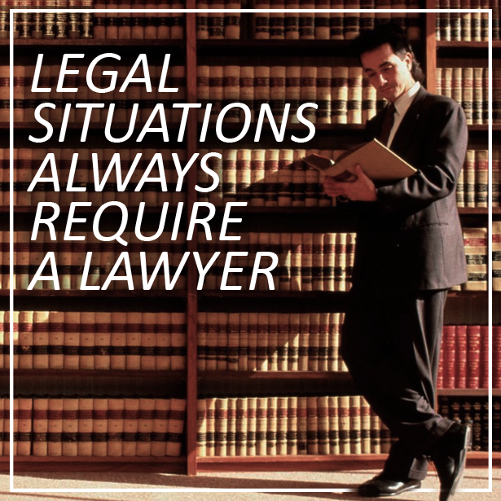

No matter what legal situation you may find yourself in, you need an experienced lawyer who will turn the tides in your favor. Visit http://www.craveylaw.com/ to learn about the services we offer.



Any delay in action when a legal situation arises will only cause more issues. Law Office of Robin T. Cravey will go above and beyond to solve your problems. Don't hesitate -- call (512) 236-9655 the minute you need legal help.